# Weekly Project Meeting Minutes

*The main purpose of the document is to capture all the work that has been done by the group over the course of one week and* ***not*** *to write down what was discussed in a single meeting. You should be meeting and/or working throughout the week*.

Time group spent on project: _____9 hours__________

Group Number: 01

Group members present (Name, ID):

* Jasleen (0734327)
* Arvind Sharma (0730475)
* Harpreet Kaur (0733894)

Specific Activities from prior week:

* List brief description of activities carried out **by group member**

This week we discuss regarding the major goals we are dealing with such as report writing and the Jupyter Notebook. Arvind Sharma is working with Report writing in which subtask are Introduction and Literature Review.

Harpreet is working on Jupyter notebook by performing a model i.e. Logistic Regression.

Jasleen also working on Jupyter notebook and did the model which is the Decision Tree.

Specific Output from prior week:

* Include brief summary of any written work, experiments, or code developed

As we have started the report writing with the Introduction and literature review in which we have covered 5 research papers till now and we are providing the overview of those research papers in this meeting of minutes and we also perform two models i.e. Logistic Regression and Decision Tree.

* Attach actual output as a separate file when submitting minutes; for example, export your Jupiter notebook as an html file and upload that with your minutes.

**Literature Review:** Some of the related work done in the report are as follow: -

* **Loan Approval Prediction based on Machine Learning Approach: -** In this paper they try to reduce the risk factor behind selecting the safe person to save lots of bankaefforts and assets. This is finished by mining the Big Data of the past records of the individuals to whom the credit was allowed previously and based on these records/encounters the machine was preparedautilizing the AI model which give the mostaprecise outcome. The primary goal of this paper is to anticipate in the case ofaallotting the advance to specific individualawill be protected or not.
* **Literature Review on Mortgage Default: -** This propositionamanufactures a DSGE model drawing on various commitments in the writing using a loan market, lodgingamarkets, and obligationadefault. The beginning stage is a model with budgetary grindings on the interest side foracredit to which I add a housingasector, a financial sector and endogenous debtadefault. The model gives a system to comprehend the effect of house value vacillations, fiscal approach, request stuns, and credit accessibility on the economy and theamanners by which money related guideline can hose blast and bustacycles in the lodging market.
* **Short Term Prediction of Mortgage Default Using Ensembled Machine Models: -** In this project theyawill determine how reusing pretrained machine learning models, on new datasets affectatheir predictive capabilities over time. This strategyafor utilizing momentary prescientamodels prepared on yearly datasets brings about both high an accuracyaand high review. The best performing calculations are a blend of boosting classifiers and ensembled choice trees with parameter enhancement bringing about huge execution increments, particularly for boosting calculations. Model assembling brought aboutaa couple of select cases with higher f1 scores than singleamodels, where averaging classaprobabilities is a particular technique for joining class expectations. At last, reusing pretrained models isademonstrated to be valuable in specific cases, yet the impact of their prescient capacities after some time are either sporadic or conflicting.
* **The Role of Technology in Mortgage Lending: -** In this project they show that FinTech moneylenders process contract applications quicker thanadifferent moneylenders, in any event, whileacontrolling for nitty gritty credit, borrower, and geographic observables. Quicker handling doesn't come at the expense of higher defaults. FinTech loan specialists modify supply more flexibly than different banks considering exogenous homealoan request stuns, in this manner limit limitations related with customaryahome loan loaning. In regions with more FinTech loaning, borrowers renegotiate more, particularly when it is to their greatest advantage to do as such. We discover no proof that FinTech banks target negligible borrowers. Our outcomes propose thatamechanical development hasaimproved the productivity of monetary intermediation in the U.S. contract advertise.
* **Loan Prediction Project using Machine Learning in Python: -** In this project they tell us theainformation of some anticipated advances from history. So, when there is name of certain 'Information' there is a ton intriguing foraInformation Scientists. I haveainvestigated dataset and discovered a ton intriguing reality about advance expectation. The initial segment is going to concentrate on information investigation and Dataarepresentation. The second one we are goingato see the about calculation used toahandle our concern.

**Model Building: -** Till now we perform two model for checking the accuracy.

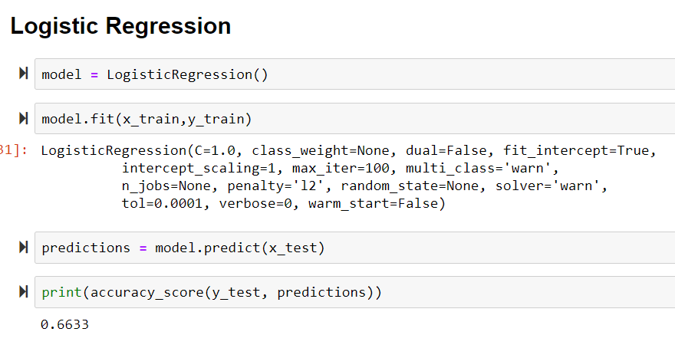

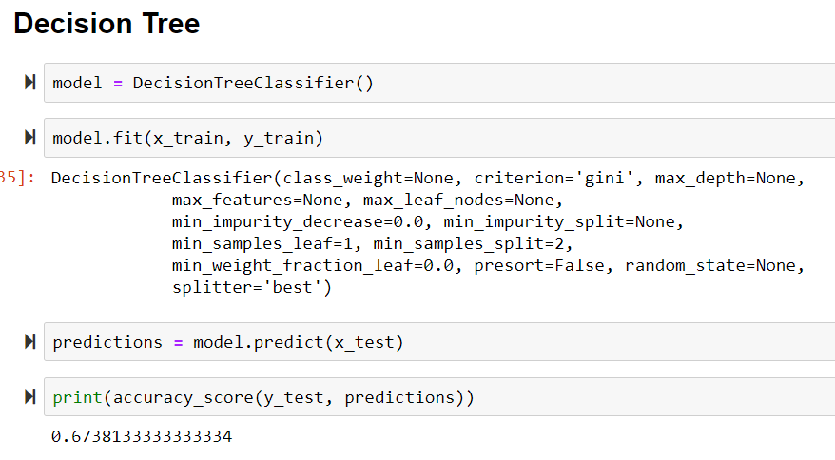

As you can clearly see that till now decision tree has the best accuracy for our dataset, but there is a slight difference between the accuracies of these models. Further we will work on different models and then compare those accuracies and select the best model from them.

On Target:

* Indicate the current status of your project
  + _____ green: everything on track for completion by due date



* + _____ yellow: a small number of tasks are off track and completion by due date is at risk
  + _____ red: many tasks are off track and project will not be completed by due date

Challenges/Disagreements:

* List any particular challenges identified/discussed and possible solutions

Yes, there is a challenge in splitting the train and test data set as we had two csv files for our project, then we concatenated these two to solve this challenge. But there is no disagreement between us.

* + include tasks causing a yellow or red flag for your project
* List any notable disagreements and subsequent discussion and resolution

Planned Activities for coming week:

* List brief description of activities **by group member**

Next week we will be continuing the modelabuilding and the report writing and try to complete the project withagood accuracy.